Author: Asif Sayyad

**NoSQL – Assignment 2**

**Create Shard using MongoDB**

**Config server – {27010,27011,27012} Shard server – {27020,27021,27022} Mongos router- 27015**

**Step 1:** start config server

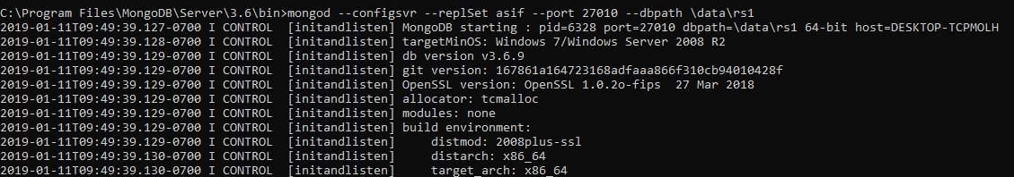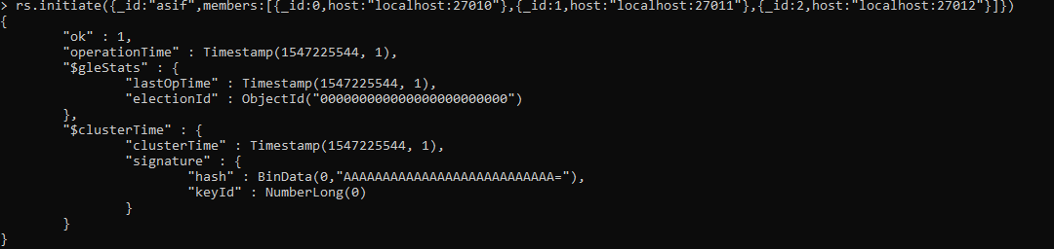

**Step 2**: start shard server one by one

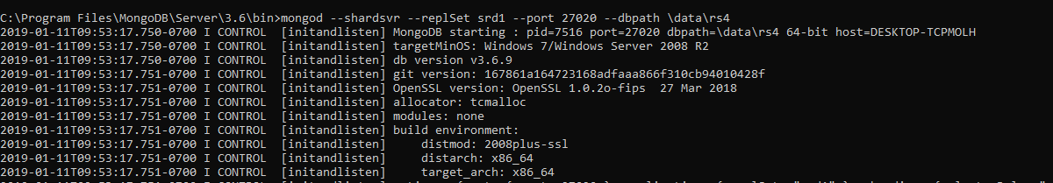



**Step 3**: Start the mongos instance by specifying the configuration server

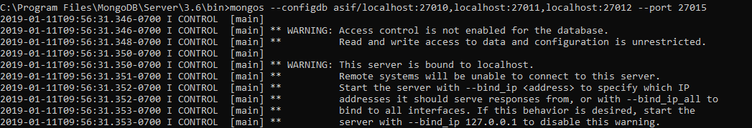

**Step 4**: use shell to connect mongos and if we have Server A and Server B which needs to be added to the cluster, issue the below commands

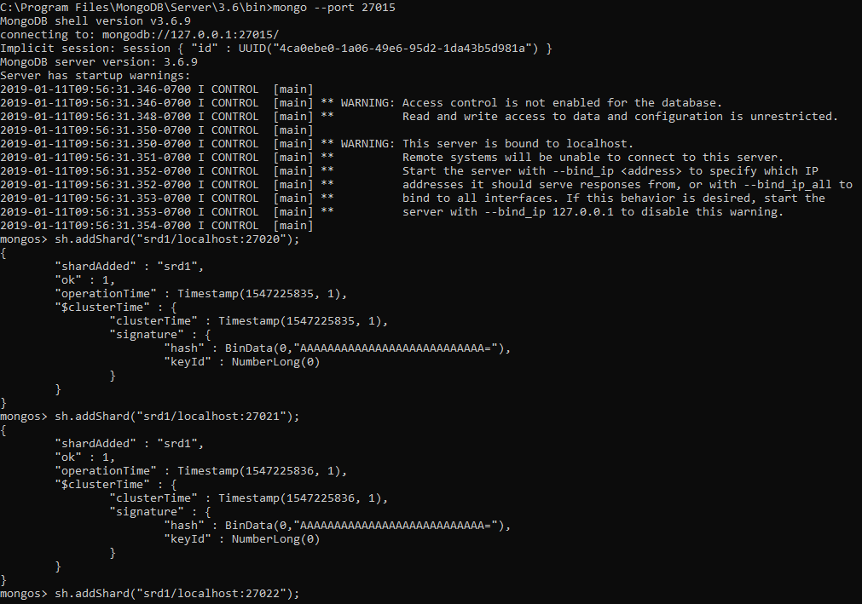

**Step 5**: Import airport data in database

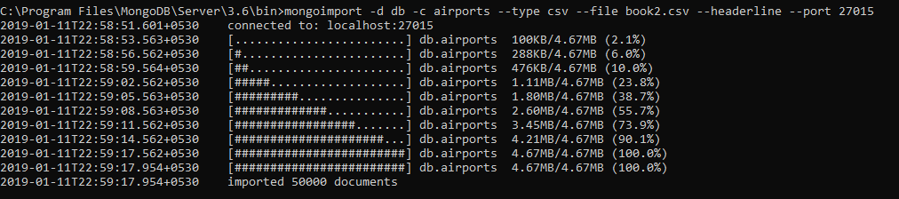

**Step 6**: Enable sharding for the database. So, if we need to shard the airport database, issue the below command

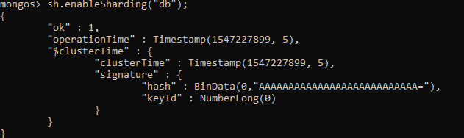

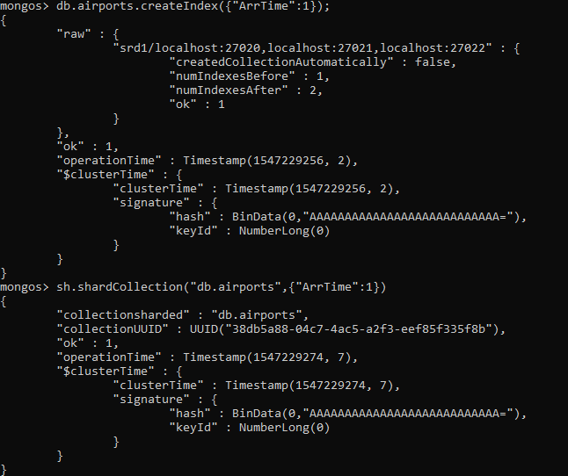

# updateOne() :

**load.js**

var before=new Date() db.airports.updateOne({"DepTime":556},{$set:{"Dest":"USA"}}).explain("executionStats") var after=new Date()

exec_time=after-before print(exec_time+"ms")

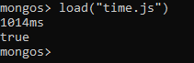

# updateMany() :

db.airports.updateMany({"DepTime":556}, {$set: {UniqueCarrier: "YZ"}})

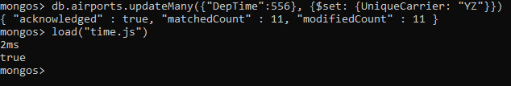

# find()

* 1. **lte**

db.airports.find({"DepTime":{$lte:556}}).explain('executionStats')

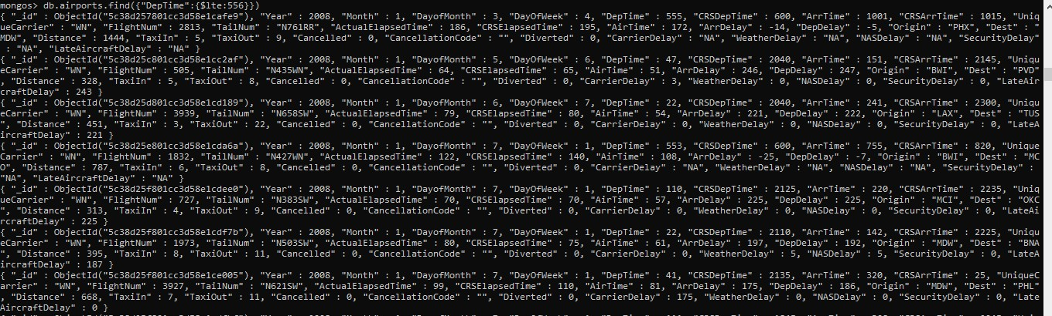

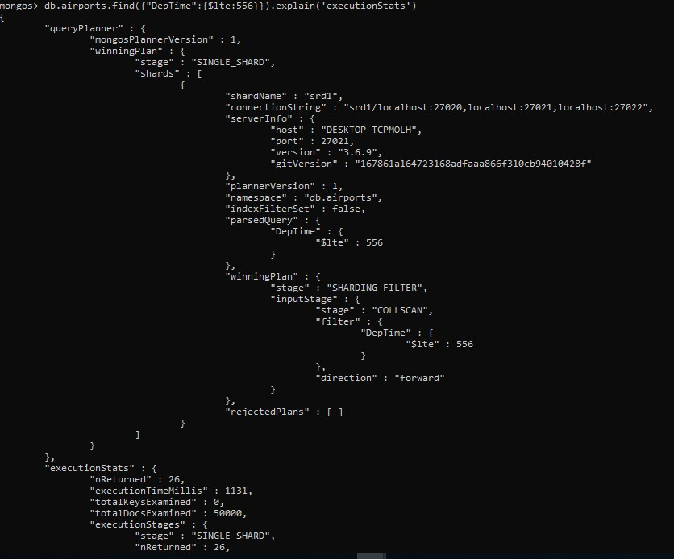

# gte

db.airports.find({"DepTime":{$gte:556}}).explain('executionStats')

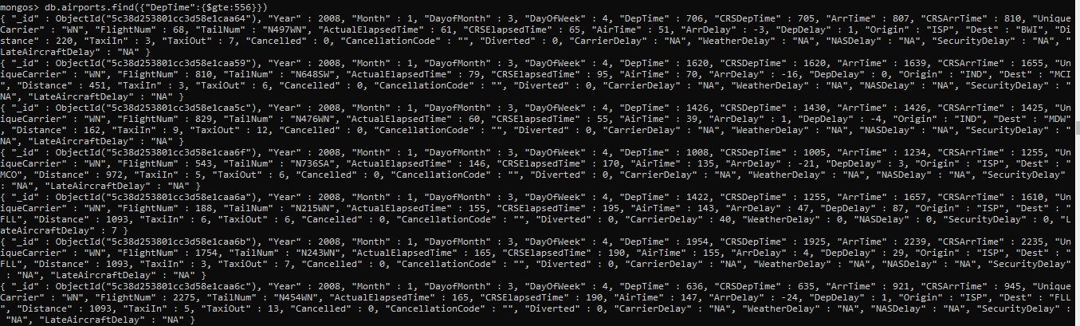

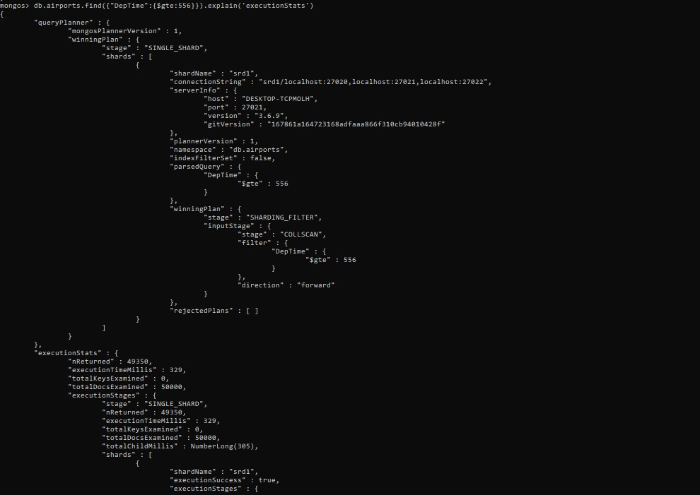

# $all

db.airports.find({"Dest":{$all:["IND"]}})

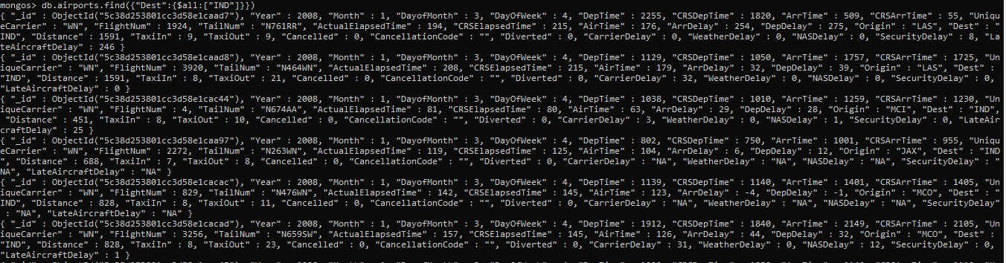

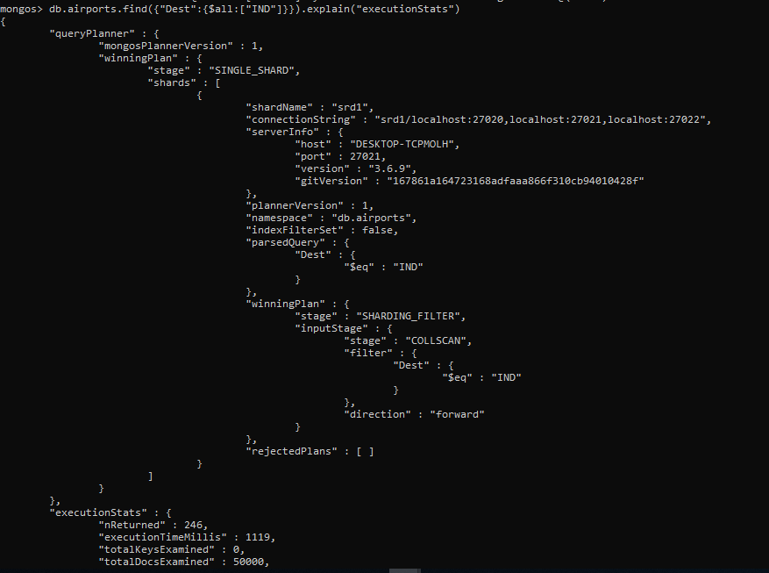

# $elemMatch

db.airports.findOne({"ArrTime":{$elemMatch:{$gte:2200}}})

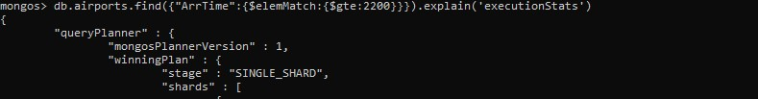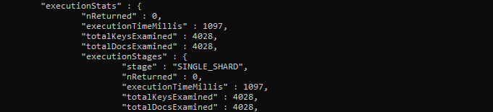

# slice :

db.airports.find({“ArrTime”:{$gt:2000},{“TailNum”:{$slice:3}}).explain(‘executionStats’)

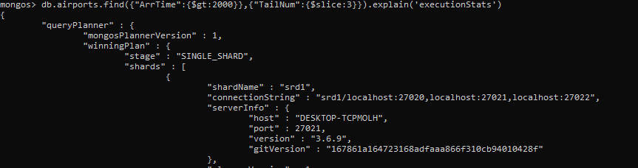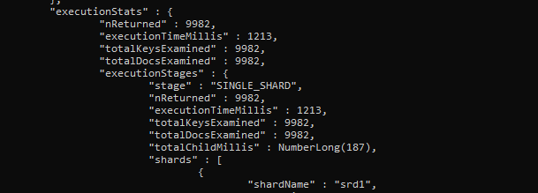

# $exists :

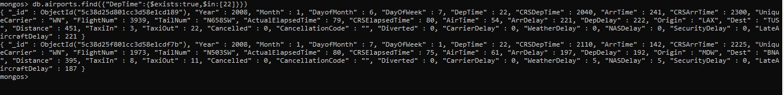

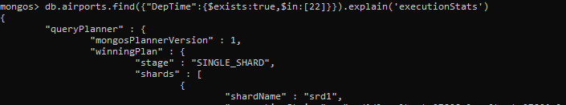

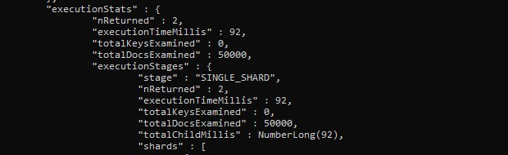

* 1. **find(). limit()**

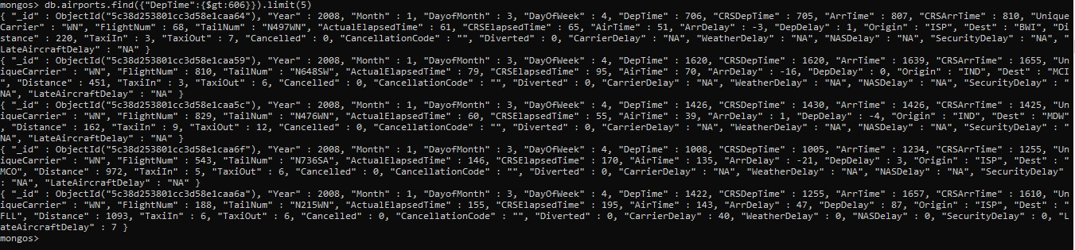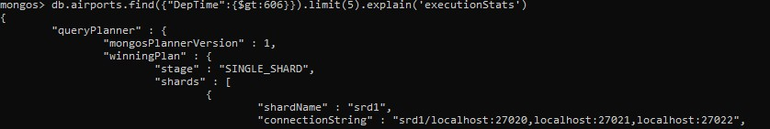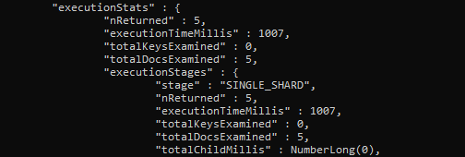

1. **MapReduce() :**

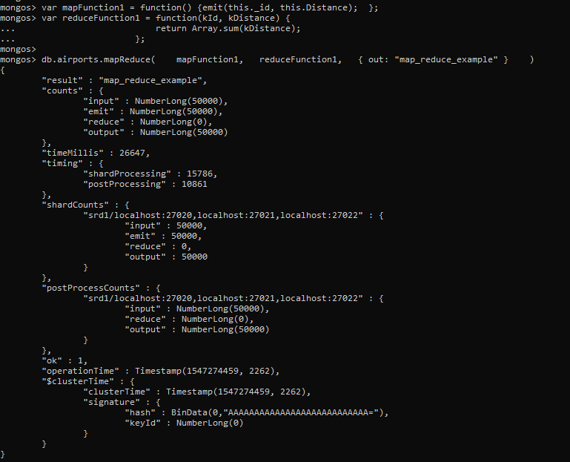

1. **Aggregate() :**

